Draw & Joint keypoints
Get confidence score
Model inference using TF
Scale values
Color segmentation
Dilation & Erosion
Creation of boundary box for each ball
Body Key-points detection (Movenet & Tensorflow - OpenCV)
Creation of boundary box for cone object
Find Contour of Balls, remove the false detections
Dilation & Erosion
Find Contour of cones
Convert to HSV
Ball detection
using Color, Circles & size
X,Y
array
X,Y
array
Convert to RGB
Crop & Resize
Decode Keypoints
Gaussian Filter
To reduce the noise
Resize the frames
Input Video frames

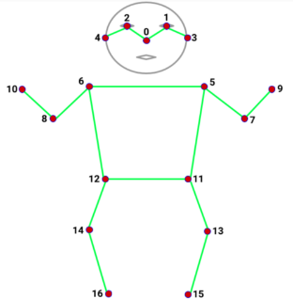

Keypoints, ball and cones detection Algorithm

Classification

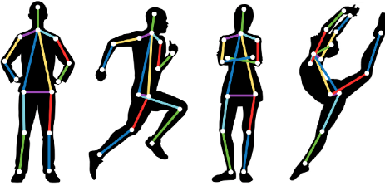
Skilled Movements Classification

Coordinates of cones, balls, other beacons
Select some of Key-points according to the play type (time series)

Simple Movements Classification

Select some of Key-points according to the play type
Coordinates of cones, balls, other beacons
Generate a CSV file contains the features of the movement

Training using KNN or SVM
Classification according to difference between correct and false training
Correlation, distance measure, speed, peaks values, time

Testing and classification
Display the results
Display the results

